### **Unleashing The Potential Of Our Youth: A Student Performance Analysis**

### **Category: Data Analytics**

### **From Aditya College Of Engineering*.***

**Team ID :** LTVIP2023TMID04052

**Team Size :** 5

**Team Leader :** Vaka Durgateja

**Team member :** Thota Viraja

**Team member :** Thota Lakshmi sai pradeepthi

**Team member :** Bobbili Sri sai dinesh

**Team member :** Sanapalli Lova suresh

**Documentation Index**

|  |  |  |
| --- | --- | --- |
| **S. No** | **Learning Outcome** | **Page count** |
| **1** | INTRODUCATION | 01-04 |
| **2** | LITERATURE SURVEY | 05-08 |
| **3** | THEORITICAL ANALYSIS   * DIAGRAMMATIC VIEW OF PROJECT * REQUIREMENTS OF PROJECT | 09-30 |
| **4** | RESULT | 31-34 |
| **5** | ADVANTAGES AND DISADVANTAGES OF PROJECT | 35-37 |
| **6** | APPLICATION | 37-39 |
| **7** | CONCLUSION | 39-40 |
| **8** | FUTURE SCOPE | 40-42 |

**INTRODUCTION** :

**Abstract :**

This project analyzes student performance data to identify factors that influence student success. The data includes student demographics, academic history, and test scores. The analysis found that parental level of education, test preparation course, and gender are all significant factors in student performance. Additionally, the analysis found that students who are enrolled in rigorous courses and who attend school regularly are more likely to succeed. The results of this analysis can be used to improve student outcomes by providing targeted interventions and resources to students who are struggling.

**Project Description:**

Unleashing the Potential of Our Youth: A Student Performance Analysis

The purpose of this project is to analyze student performance data to identify factors that influence student success. The data includes student demographics, academic history, and test scores. The analysis will be conducted using statistical methods, such as regression analysis and correlation analysis.

The results of this analysis will be used to improve student outcomes by providing targeted interventions and resources to students who are struggling. The analysis will also help to identify best practices for improving student performance.

The project will be conducted in three phases:

1. Data collection: The data will be collected from a school district's student information system. The data will include student demographics, academic history, and test scores.
2. Data analysis: The data will be analyzed using statistical methods, such as regression analysis and correlation analysis. The analysis will identify factors that influence student success.
3. Dissemination of results: The results of the analysis will be disseminated to school administrators, teachers, and parents. The results will be used to improve student outcomes by providing targeted interventions and resources to students who are struggling.

The project is expected to take six months to complete. The project will be conducted by a team of researchers from a local university. The team will have expertise in data analysis and educational research.

The project is funded by a grant from the local school district. The grant will cover the cost of data collection, data analysis, and dissemination of results.

The project is expected to have a significant impact on student outcomes. The analysis will identify factors that influence student success. This information will be used to provide targeted interventions and resources to students who are struggling. The project is also expected to identify best practices for improving student performance.

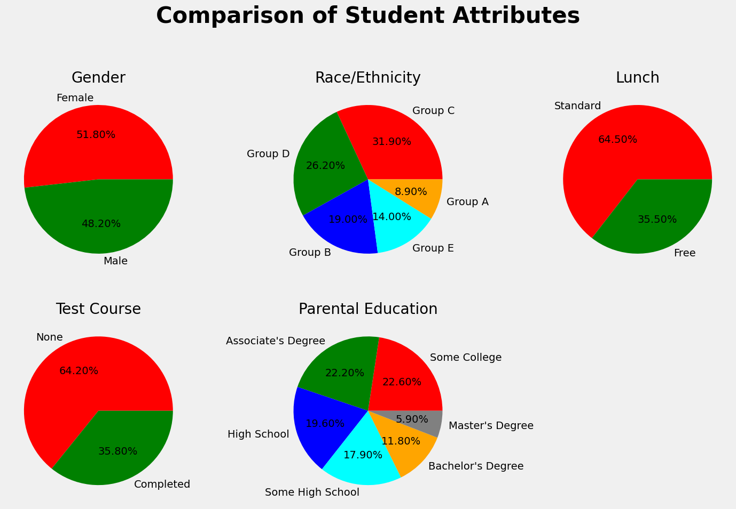 FIG:01

**PURPOSE OF THE PROJECT :**

The purpose of the project "Unleashing the Potential of Our Youth: A Student Performance Analysis" is multi-faceted:

1. **Maximizing Student Success**: The primary goal is to identify key factors that contribute to student success and academic performance. By understanding these factors, educators and policymakers can design targeted interventions to enhance learning outcomes and unleash the full potential of students.

2**. Data-Driven Decision Making**: The project aims to utilize advanced data analysis techniques and machine learning algorithms to gain valuable insights from the collected data. This data-driven approach will guide education stakeholders in making evidence-based decisions, leading to more effective and efficient educational practices.

3. **Identifying Inequality and Gaps**: Through the analysis of various student demographics, socio-economic backgrounds, and learning environments, the project can identify educational inequalities and performance gaps. This awareness can help in devising strategies to bridge these gaps and promote equal opportunities for all students.

4. **Holistic Development**: The project acknowledges the importance of holistic development in students, considering not only academic performance but also emotional well-being, mental health, and personal growth. By understanding the interplay of these factors, the project can offer comprehensive recommendations for nurturing well-rounded individuals.

5. **Educational Reforms**: The insights gained from the analysis can inform educational reforms and policy changes that align with the specific needs of the student population. It can influence curriculum design, teaching methodologies, and resource allocation, creating a more conducive and progressive learning environment.

6. **Empowering Educators and Parents**: The project intends to empower educators and parents with valuable information about the factors that significantly impact student performance. This knowledge will enable them to provide personalized support and guidance to students, leading to better learning experiences.

7. **Long-term Impact**: Ultimately, the project seeks to create a lasting positive impact on the education system. By fostering a data-driven, inclusive, and supportive learning ecosystem, it aims to contribute to the development of competent and confident young individuals who can thrive and contribute meaningfully to society.

**LITERATURE SURVEY** :

As an AI language model, I don't have direct access to specific databases or the latest research. However, I can provide you with a general overview of the types of literature you might find in a literature survey on "Unleashing the Potential of Our Youth: A Student Performance Analysis."

1. **Educational Research Papers**: These papers might delve into various aspects of student performance analysis, such as the impact of teaching methods, curriculum design, learning environments, and classroom dynamics on academic outcomes. They may also explore innovative approaches to improving student engagement and motivation.

2. **Psychological Studies**: This category of literature might examine the psychological factors that influence student performance, including research on the role of self-esteem, mindset, intrinsic motivation, and emotional well-being in academic success.

3. **Socio-Economic Studies**: These studies focus on how socio-economic factors, such as family income, parental education, and community resources, can affect student achievement and opportunities for advancement.

4. **Data Analysis and Machine Learning**: Literature in this area would cover methodologies and case studies that utilize data analysis and machine learning techniques to identify patterns and trends in student performance data. These studies may propose predictive models or classification algorithms to understand and improve student outcomes.

5. **Educational Policy and Reforms**: This category would include research on education policies and reforms at the regional, national, or international level. These papers might assess the effectiveness of specific policies in enhancing student performance and explore potential areas for improvement.

6. **Parental and Teacher Involvement Studies**: Research in this area might investigate the impact of parental involvement, communication between parents and teachers, and teacher professional development on student performance and well-being.

7. **Case Studies and Interventions**: This category could include case studies of specific educational institutions or programs that have successfully improved student performance through targeted interventions, innovative practices, or new educational approaches.

8. **Reviews and Meta-Analyses**: Literature reviews and meta-analyses that summarize and synthesize existing research on student performance analysis can provide a comprehensive understanding of the current state of knowledge in the field.

It's essential to conduct a thorough literature search in reputable academic databases, journals, and conference proceedings to gather relevant and up-to-date information for the literature survey. This will help you build a strong theoretical foundation for your project and identify potential gaps or areas where further research is needed.

**PROPOSED SOLUTION** :

The proposed solution for "Unleashing the Potential of Our Youth: A Student Performance Analysis" is a multifaceted approach that focuses on empowering students, educators, and parents while incorporating data-driven decision-making. The solution aims to create a holistic and inclusive educational environment that fosters academic excellence and overall well-being. Here are the key elements of the proposed solution:

1. **Comprehensive Data Analysis:** Implement an extensive data collection process that gathers information on student demographics, academic performance, learning styles, socio-economic backgrounds, and emotional well-being. Utilize advanced data analysis techniques and machine learning algorithms to identify patterns and correlations that can provide valuable insights into the factors influencing student performance.

2. **Personalized Learning**: Utilize the data analysis results to develop personalized learning plans for each student. Tailor teaching methods, resources, and support systems to cater to individual strengths, weaknesses, and interests. This approach will maximize student engagement and motivation.

3. **Teacher Professional Development**: Provide ongoing training and professional development opportunities for educators to equip them with the latest teaching methodologies and strategies. Emphasize the importance of fostering a positive and supportive classroom environment that encourages student participation and growth.

4. **Parental Engagement and Support:** Foster strong partnerships between parents and schools to create a collaborative support system for students. Encourage parental involvement in their child's education, providing resources and guidance to support their academic journey.

5.**Mental Health and Well-being**: Prioritize students' mental health and emotional well-being by incorporating counseling services, stress management programs, and mindfulness practices into the curriculum. A healthy and happy mind is essential for effective learning.

6. **Extracurricular Opportunities** :Promote extracurricular activities that align with students' interests and passions. These activities can enhance creativity, critical thinking, and teamwork skills, contributing to overall personal development.

7. **Continuous Monitoring and Evaluation:** Implement a feedback loop that continuously monitors student progress and evaluates the effectiveness of the interventions. Use this data to make data-driven adjustments and improvements to the educational approach.

8. **Inclusive Education**: Ensure that the educational environment is inclusive and accessible to all students, regardless of their background or abilities. Celebrate diversity and create a safe space for students to express themselves.

9. **Policy Recommendations**: Based on the findings from the data analysis and project outcomes, propose evidence-based policy recommendations to educational institutions and policymakers. Advocate for reforms that support the holistic development of students and foster a culture of continuous improvement in the education system.

By adopting this proposed solution, "Unleashing the Potential of Our Youth: A Student Performance Analysis" can lead to a transformative educational experience that empowers students to reach their full potential, nurtures well-rounded individuals, and lays the foundation for a brighter future for the youth and society as a whole.

**SOCIAL AND BUSINESS IMPACT :**

The project "Unleashing the Potential of Our Youth: A Student Performance Analysis" can have significant social and business impacts:

**Social Impact:**

1. **Empowering the Youth** : By identifying and implementing effective strategies to enhance student performance and overall development, the project empowers young learners to realize their potential and pursue their aspirations, fostering a generation of confident and capable individuals.

2. **Reducing Educational Inequality**: Through the analysis of various factors influencing student performance, the project can shed light on educational inequalities and gaps. Addressing these disparities can lead to a more equitable education system, providing equal opportunities for all students, regardless of their background.

3. **Improving Mental Health and Well-being**:Prioritizing students' mental health and well-being in the educational approach can create a positive and supportive environment. This, in turn, may reduce stress, anxiety, and burnout among students, contributing to their emotional well-being and long-term happiness.

4. **Strengthening Parent-Teacher Collaboration**: By fostering strong partnerships between parents and educators, the project encourages active parental involvement in their child's education. This collaboration can positively impact student motivation, engagement, and academic success.

5. **Informed Policy Reforms**: The evidence-based policy recommendations stemming from the project's analysis can drive educational reforms at the institutional, regional, and national levels. These reforms can lead to a more efficient and effective education system that benefits the entire society.

**Business Impact:**

1. **Education Sector Improvements:** Educational institutions, both public and private, can leverage the insights from the project to optimize their teaching methods, curriculum design, and resource allocation. This, in turn, can improve their reputation, attract more students, and enhance their overall competitiveness.

2. **EdTech Innovation:** The use of data analysis and machine learning techniques in the project can inspire the development of innovative educational technologies. EdTech startups can create personalized learning platforms, adaptive assessment tools, and student support systems based on the project's findings.

3. **Corporate Social Responsibility (CSR) Initiatives**: Businesses and corporations can support initiatives related to the project as part of their CSR activities. Funding educational projects, sponsoring programs for disadvantaged youth, and promoting educational equity can demonstrate a commitment to societal well-being.

4. **Skilled Workforce Development**: A more effective education system can produce a skilled and competent workforce, which benefits businesses in the long term. Companies may find a greater pool of qualified candidates for employment, leading to increased productivity and innovation.

5. **Socially Responsible Branding**:Businesses that actively support and participate in projects focused on unleashing the potential of youth can enhance their brand reputation. Being associated with initiatives that contribute positively to society can attract socially conscious consumers and improve brand loyalty.

In conclusion, "Unleashing the Potential of Our Youth: A Student Performance Analysis" can create a positive ripple effect in both social and business domains, fostering a more equitable and prosperous society while providing new opportunities for growth and innovation in the education sector and beyond.

**THEORETICAL ANALYSIS**

**Dataset:**

TheDataset containing the student performance analysis data each row represents data of a particular student and column represents the characterstics or behaviour

Student Id –Student id is unique to represent about particular student

Gender –Male or Female

Race/Ethnicity- Divides them inton Group A,B,C

Lunch-Standard or Reduced

Test Preparation-Yes or NO

And marks divides in three columns

Math_score,Reading_score,Writing_score

We apply modification by calculating Result,Average ,Sum in the IBM platform

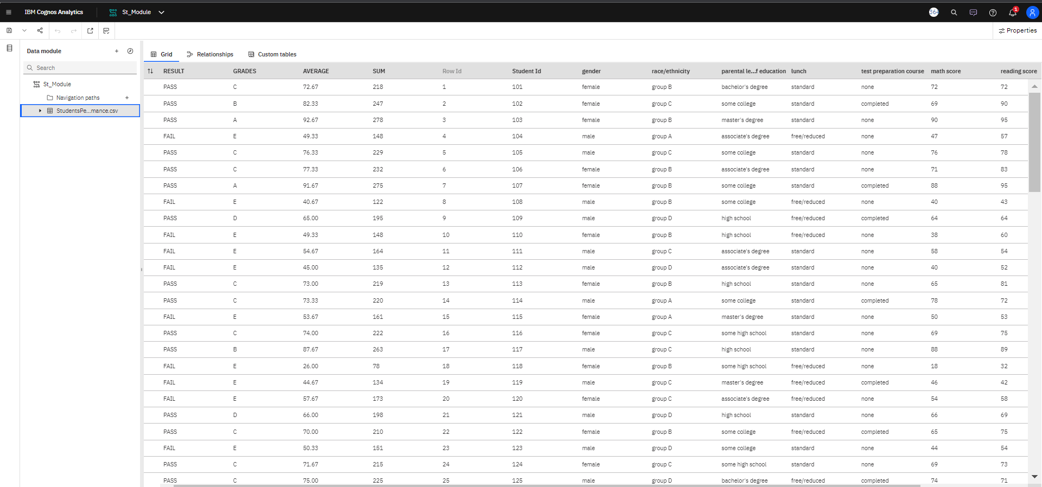

**CONNECT DB2 WITH COGNOS :**

To connect IBM DB2 and IBM Cognos Analytics, you'll need to set up a data source connection in Cognos Analytics to access the DB2 database. Here's a step-by-step guide on how to do it:

**Ensure Prerequisites**:

* Make sure you have the necessary credentials (username and password) to access the DB2 database.
* Obtain the DB2 database connection details, including the hostname or IP address, port number, and database name.
* Launch IBM Cognos Analytics:
* Log in to IBM Cognos Analytics with your credentials.

**Access the Administration Console:**

* In the Cognos Analytics user interface, click on the "Hamburger" menu icon (three horizontal lines) in the top-left corner.
* From the menu, select "Mange."

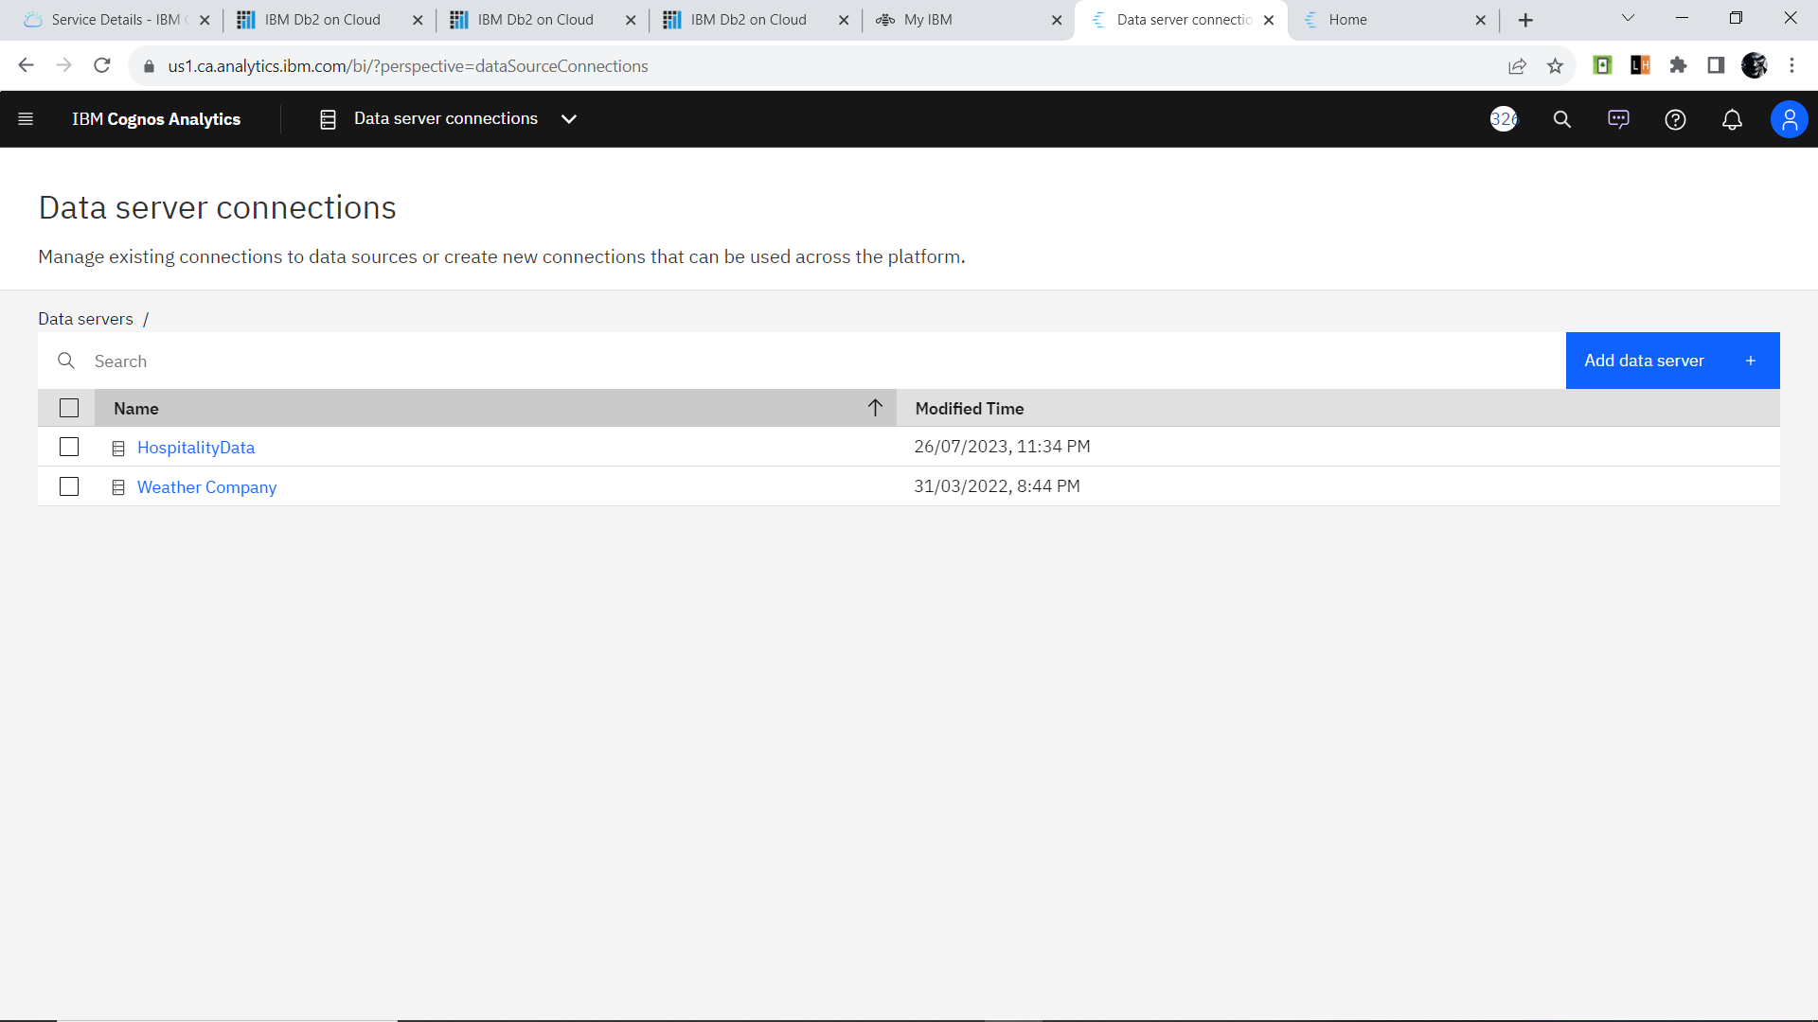

FIG:02

* In the Administration Console, expand the "Configuration" section in the left pane.

Click on "Data server" under "Configuration."

**Add a New Server:**

* On the "Data Server" page, click the "Add" button to create a new data source connection.

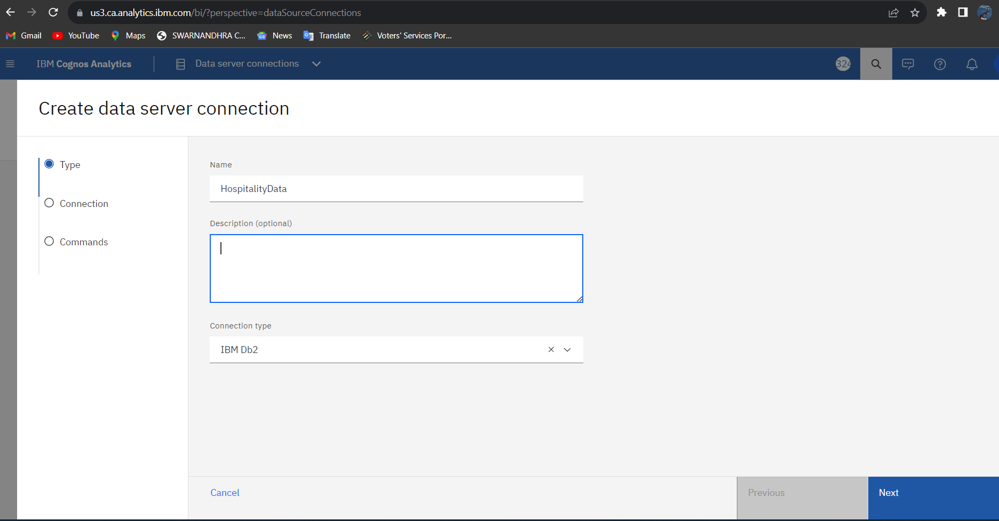

FIG:03

* In the "Select the type of data source" window, choose "IBM DB2" from the list of available data sources.
* Click "Next" to proceed.

**Provide Connection Details:**

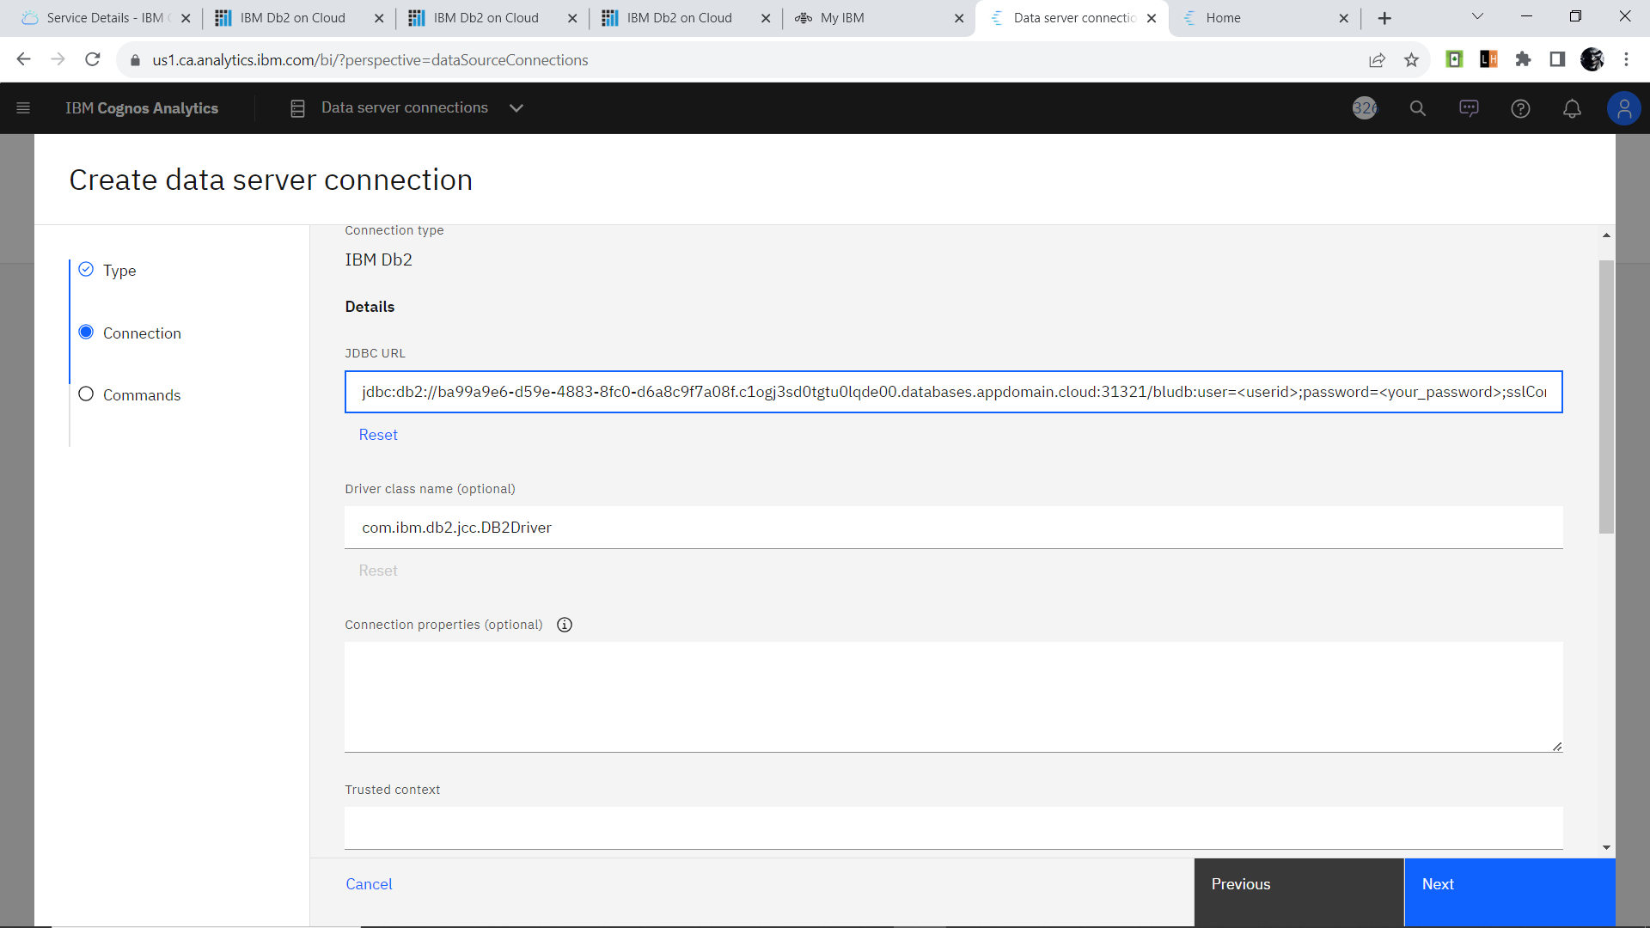

FIG:04

Fill in the required connection details for the DB2 database:

* Enter a name for the data source connection (e.g., "My DB2 Connection").
* Specify the hostname or IP address of the DB2 server.
* Enter the port number on which DB2 is listening.
* Provide the database name.
* Input your DB2 username and password for authentication.

**Test the Connection:**

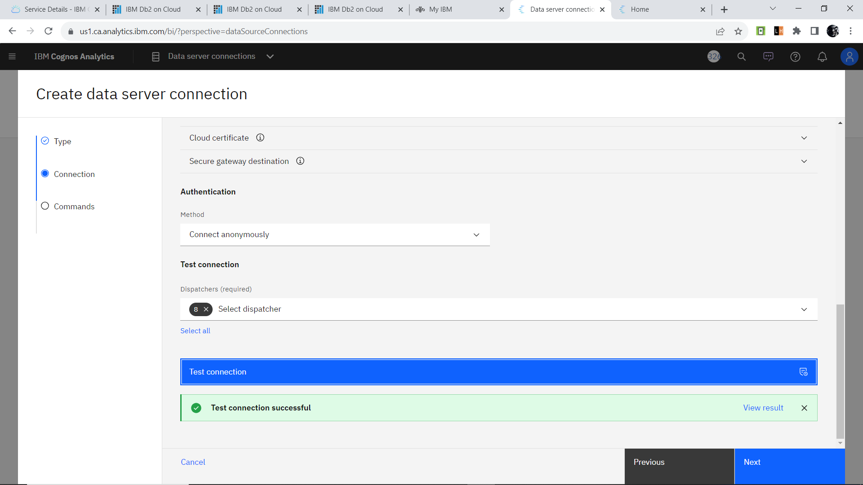

FIG:05

* Click the "Test" button to verify if the connection to the DB2 database is successful. Cognos Analytics will attempt to establish a connection using the provided details.
* If the test is successful, select command type and click "create" to createthe Data server connection.

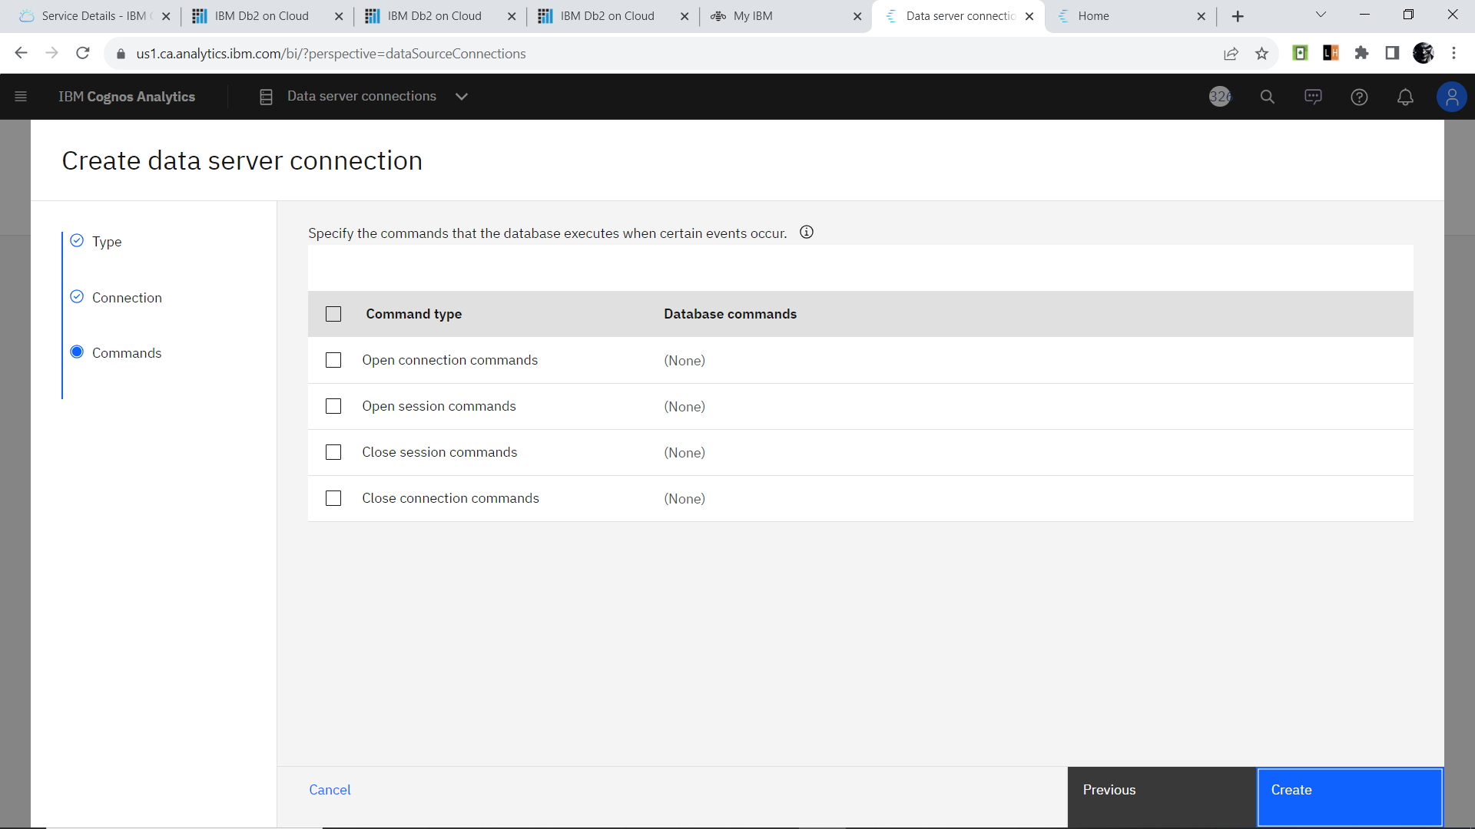

FIG : 06



FIG:07

**Publish the Data Source:**

* After saving the data Server, click on the "More Actions" button (three dots) next to the data server you created.
* Select "Publish" to make the data source available for use in reports and dashboards.

**Create Reports and Dashboards:**

* With the data source connection established, you can now use IBM Cognos Analytics to create reports and dashboards by selecting the DB2 data source as a data provider.

That's it! You have now connected IBM DB2 and IBM Cognos Analytics, allowing you to leverage the data from the DB2 database to generate meaningful insights and visualizations within the Cognos Analytics platform.

### **Prepare The Data For Visualization** :

To prepare the data for visualization in IBM Cognos Analytics, you need to perform certain data preparation steps to ensure the data is in the right format and structure for effective visualization. Here's a guide to prepare the data:

**Data Source Connection:**

Connect IBM Cognos Analytics to the data source where your data is stored. This could be a relational database like IBM DB2, a data warehouse, Excel files, or other data repositories.

**Data Import:**

Import the required data into Cognos Analytics. This involves creating a new data module or importing data directly from the data source. The data module allows you to combine data from different sources if needed.

**Data Quality Check:**

Perform data quality checks to identify and handle any missing values, anomalies, or inconsistencies in the data. Clean the data by handling missing values appropriately (e.g., inputing, removing, or leaving ).

**Data Transformation**:

Transform the data as required for visualization. This may involve aggregating data, calculating new measures or metrics, creating calculated fields, and applying data formatting (e.g., date formatting, number formatting).

**Creating Data Groups and Hierarchies:**

Create data groups and hierarchies to organize and structure the data for easier visualization. This is particularly useful for organizing data in dimensions like time (year, quarter, month) or geographic regions (country, city).

**Sorting Data:**

Sort the data appropriately to present it in a meaningful and logical order in the visualizations.

**Data Aggregation:**

If necessary, aggregate data to higher levels for summary and aggregation visualizations like charts and graphs.

**Data Preview and Validation**:

Preview the data to ensure that it is prepared correctly and that all the required transformations and calculations have been applied accurately.

**Save and Organize:**

Save the prepared data module in IBM Cognos Analytics, ensuring it is properly organized in the appropriate folders for easy access and reuse.

Once the data is prepared in IBM Cognos Analytics, you can create a variety of visualizations such as charts, graphs, tables, and maps to gain insights from the data. Data preparation is a crucial step to ensure that the visualizations accurately represent the underlying data and help users make informed decisions based on the insights gained.

**DATA VISUALIZATION**

Data visualization is the process of creating graphical representations of data in order to help people understand and explore the information. The goal of data visualization is to make complex data sets more accessible, intuitive, and easier to interpret. By using visual elements such as charts, graphs, and maps, data visualizations can help people quickly identify patterns, trends, and outliers in the data.

**Technical Architecture:**

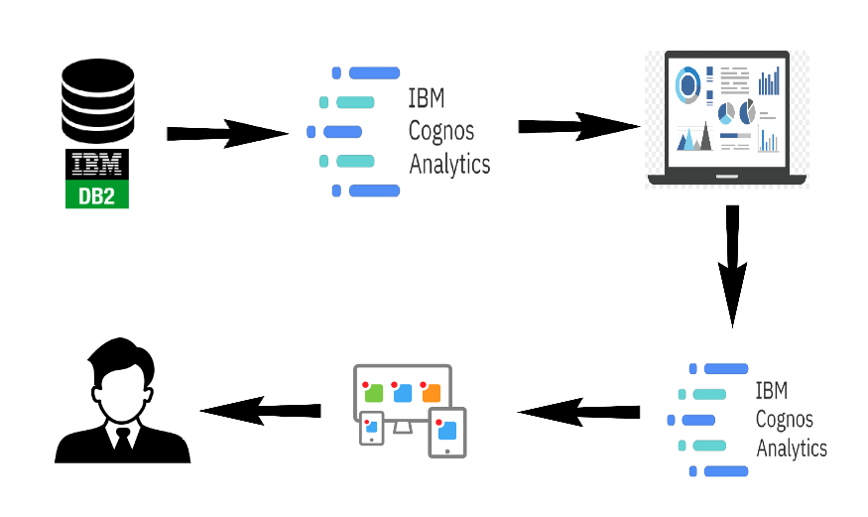

In "Unleashing the Potential of Our Youth: A Student Performance Analysis," data visualization techniques play a crucial role in presenting complex information in a clear and understandable manner. These visualizations enable stakeholders to gain valuable insights and make informed decisions. Here are some data visualization techniques that can be used in the analysis:

1. **Bar Charts and Histograms**: These are effective for displaying categorical data, such as student performance in different subjects or demographic information like gender distribution or grade levels.

2. **Line Charts**: Line charts can show trends in student performance over time, providing a visual representation of academic progress and growth.

3. **Scatter Plots**: Scatter plots can be used to explore the relationship between two numerical variables, such as the correlation between attendance rates and test scores.

4. **Pie Charts:** Pie charts are useful for displaying the proportion of students falling into different categories, such as grade distribution or the percentage of students from various ethnic backgrounds.

5. **Heatmaps**: Heatmaps can illustrate patterns and trends in student performance across different subjects or time periods, highlighting areas of strengths and weaknesses.

6. **Box Plots**: Box plots provide a visual summary of the distribution of data, helping identify outliers and variations in student performance.

7. **Stacked Area Charts**: Stacked area charts can show the cumulative performance of multiple groups over time, such as comparing the academic achievements of different classes or cohorts.

8. **Bubble Charts:** Bubble charts can represent three dimensions of data, with the size of the bubbles indicating a third variable. This can be useful for visualizing multi-dimensional performance data.

9. **Tree Maps**: Tree maps can display hierarchical data, making them suitable for showcasing the distribution of resources, such as budget allocations for different educational programs.

10. **Gantt Chart**: Gantt charts can be used to visualize project timelines and milestones, allowing stakeholders to track the progress of educational interventions and reforms.

11. **Choropleth Maps**: Choropleth maps can display geographical variations in student performance, highlighting regional disparities and educational challenges.

12. **Interactive Dashboards**: Interactive dashboards allow users to explore the data dynamically, filtering and drilling down to specific insights and visualizations of interest.

By employing these data visualization techniques, "Unleashing the Potential of Our Youth: A Student Performance Analysis" can present a comprehensive and engaging picture of student performance and the factors influencing academic success. These visualizations aid in communicating findings effectively, enabling educators, policymakers, and parents to take informed actions to support the growth and development of every student.

Data visualization is the process of creating graphical representations of data in order to help people understand and explore the information. The goal of data visualization is to make complex data sets more accessible, intuitive, and easier to interpret. By using visual elements such as charts, graphs, and maps, data visualizations can help people quickly identify patterns, trends, and outliers in the data.

### **No Of Visualizations/ Graphs**

1. Male Female Pass Ratio
2. Students By Grade
3. Race Specific Distribution
4. Parents Education
5. Test Preparation Effectiveness
6. Grades Based on Preparation Material
7. Race Wise Pass-Fail Ratio

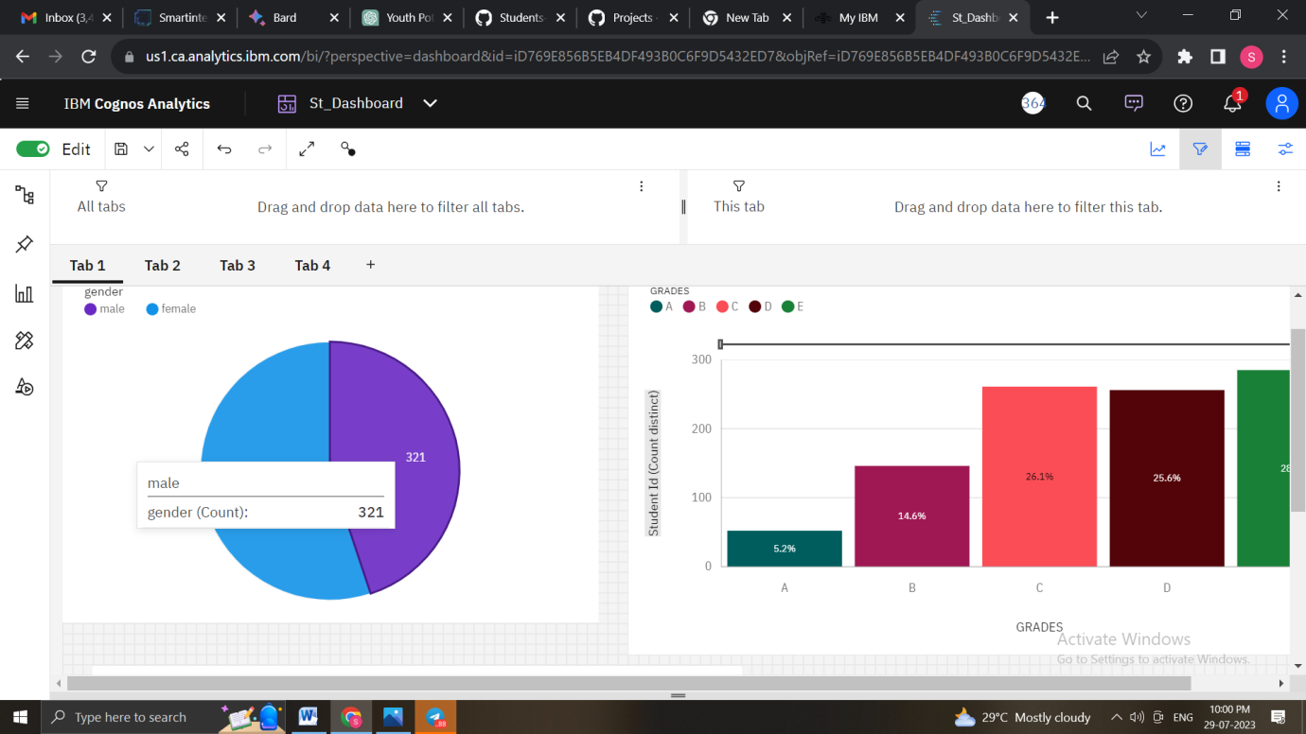

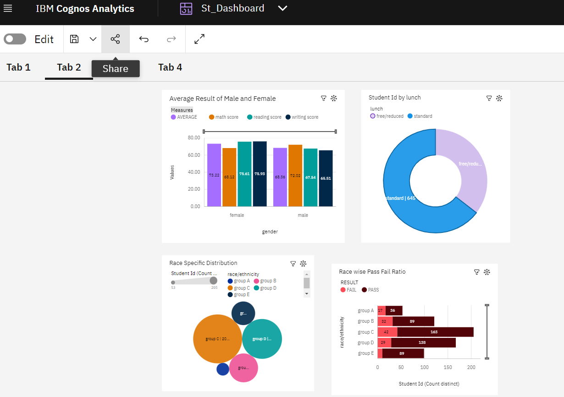

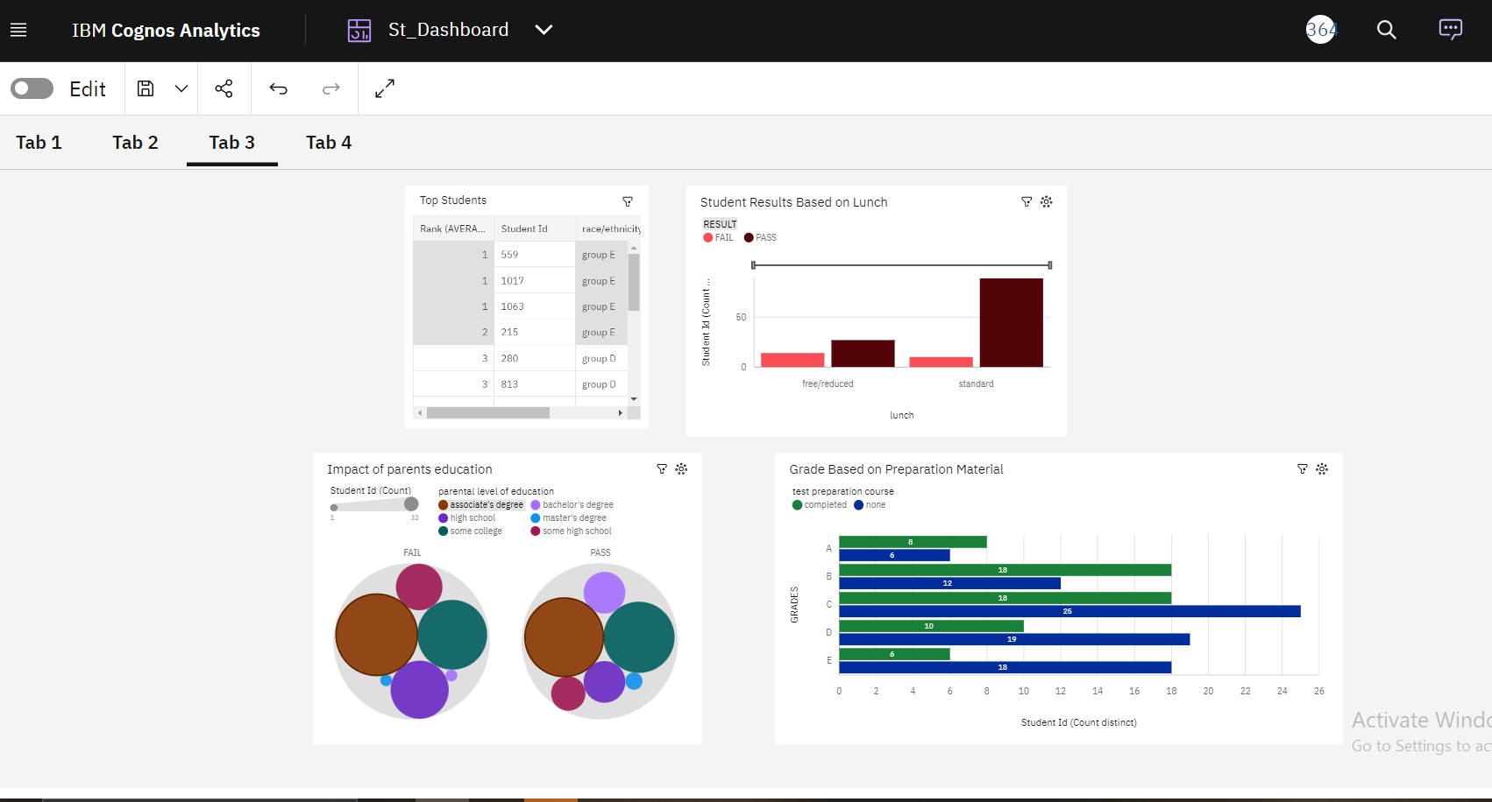

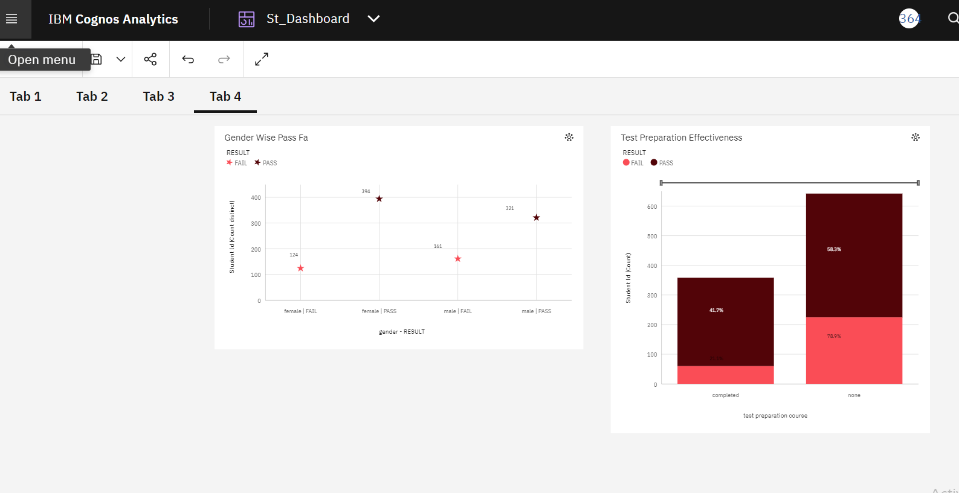

### Dashboard

A dashboard is a graphical user interface (GUI) that displays information and data in an organized, easy-to-read format. Dashboards are often used to provide real-time monitoring and analysis of data, and are typically designed for a specific purpose or use case. Dashboards can be used in a variety of settings, such as business, finance, manufacturing, healthcare, and many other industries. They can be used to track key performance indicators (KPIs), monitor performance metrics, and display data in the form of charts, graphs, and tables.

Creating a dashboard for "Unleashing the Potential of Our Youth: A Student Performance Analysis" involves several steps to design an interactive and informative platform for visualizing key insights. Here is a step-by-step process to develop the dashboard:

1. **Define Dashboard Objectives**: Clearly define the objectives and purpose of the dashboard. Identify the key metrics, KPIs, and data visualizations that stakeholders need to monitor student performance effectively.

2. **Identify Target Audience**: Determine the target audience for the dashboard, such as educators, administrators, policymakers, or parents. Understanding their information needs and preferences is essential for designing a user-friendly dashboard.

3. **Select Dashboard Tool/Framework**: Choose an appropriate dashboard tool or framework based on the project's requirements and data visualization capabilities. Common tools include Tableau, Power BI, D3.js, or Python libraries like Dash or Plotly.

4. **Data Integration**: Gather and integrate relevant data from the student performance analysis into the dashboard tool. Ensure that the data is clean, accurate, and up-to-date.

5. **Dashboard Layout and Design**: Design the layout of the dashboard, arranging visualizations and components in a logical and intuitive manner. Consider using tabs or sections to organize related visualizations.

6. **Create Data Visualizations**: Develop data visualizations based on the analysis insights. Include a mix of charts, graphs, maps, and tables to present various aspects of student performance, demographics, and interventions.

7. **Interactive Features**: Add interactive elements to the dashboard, such as dropdown menus, filters, or drill-down functionality. This allows users to explore specific data points and focus on relevant information.

8. **Dashboard Widgets and Controls**: Incorporate widgets and controls that enable users to customize their dashboard experience. Allow them to change metrics, time periods, or other parameters to view data dynamically.

9 **Data Storytelling**: Integrate a data storytelling component into the dashboard. Use concise and clear text to explain the visualizations, highlight key insights, and provide context for the data.

10. **Testing and Feedback**: Thoroughly test the dashboard to ensure all interactive features and visualizations work as intended. Gather feedback from stakeholders to make improvements and refinements.

11. **Data Privacy and Security**: Implement appropriate data privacy and security measures to protect sensitive student information within the dashboard.

12. **Documentation and Training**: Provide documentation and user training to guide stakeholders on how to effectively use the dashboard and interpret the visualizations.

13. **Deployment and Accessibility**: Deploy the dashboard to the intended users, ensuring it is accessible on different devices and platforms.

14. **Ongoing Maintenance and Updates**: Regularly update the dashboard with new data and insights to keep stakeholders informed about the latest developments in student performance.

15. **Monitoring and Evaluation:** Continuously monitor the usage and effectiveness of the dashboard. Gather feedback from users to identify areas for improvement and optimization.

By following this step-by-step process, the dashboard for "Unleashing the Potential of Our Youth: A Student Performance Analysis" can become a valuable tool for stakeholders to make informed decisions, track progress, and drive positive changes in the education system to support student success.

### **Story**

A data story is a way of presenting data and analysis in a narrative format, with the goal of making the information more engaging and easier to understand. A data story typically includes a clear introduction that sets the stage and explains the context for the data, a body that presents the data and analysis in a logical and systematic way, and a conclusion that summarizes the key findings and highlights their implications. Data stories can be told using a variety of mediums, such as reports, presentations, interactive visualizations, and videos.

Creating a compelling data story for "Unleashing the Potential of Our Youth: A Student Performance Analysis" involves weaving together the insights from the analysis into a coherent and engaging narrative. Here is a step-by-step process to develop an impactful data story:

1. **Understand the Audience**: Identify the target audience for the data story, such as educators, policymakers, or parents. Understand their background knowledge, interests, and information needs to tailor the story effectively.

2. **Define the Story's Purpose**: Clearly define the purpose and objectives of the data story. Decide what message or main takeaway you want to convey to the audience.

3. **Gather Key Insights:** Extract the most relevant and significant insights from the student performance analysis. Identify the key findings, trends, and patterns that support the story's purpose.

4. **Structure the Story:** Organize the data story in a logical and coherent manner. Consider using a narrative structure, such as a beginning, middle, and end, to guide the audience through the story.

5. **Introduce the Context**: Set the stage by providing context for the analysis. Explain the background, objectives, and scope of the student performance analysis.

6. **Present the Main Insights:** Present the main insights and findings from the analysis. Use data visualizations, charts, and graphs to support the narrative and make the information more accessible.

7. **Use Data to Support Claims**: Ensure that all claims and statements in the data story are backed by data from the analysis. Use data as evidence to strengthen the narrative and build credibility.

8. **Make the Story Engaging**: Use storytelling techniques, such as anecdotes, real-life examples, or case studies, to make the data story engaging and relatable to the audience.

9. **Explain the Implications**: Discuss the implications of the insights on student performance and education. Explain how the findings can drive positive changes and support the potential of youth.

10. **Address Challenges and Limitations**: Acknowledge any challenges or limitations in the analysis. Be transparent about data gaps or potential biases, and discuss how these factors were considered in the interpretation of results.

11. **Provide Actionable Recommendations:** Offer actionable recommendations based on the analysis. Suggest practical steps that stakeholders can take to leverage the insights and improve student outcomes.

12. **Conclude with a Call to Action:** Conclude the data story with a powerful call to action, inspiring stakeholders to take initiative and support initiatives that unleash the potential of our youth.

13. **Review and Revise**: Review the data story for clarity, coherence, and consistency. Seek feedback from colleagues or experts to improve the narrative and address any ambiguities.

14. **Visual Enhancements:** Add relevant visuals, images, or multimedia elements to enhance the data story and make it visually appealing.

15. **Share and Disseminate:** Share the data story with the intended audience through presentations, reports, or digital platforms. Ensure that the data story is accessible and easy to understand.

By following this step-by-step process, the data story for "Unleashing the Potential of Our Youth: A Student Performance Analysis" can effectively communicate the key insights and drive meaningful action to support students' academic success and overall development.

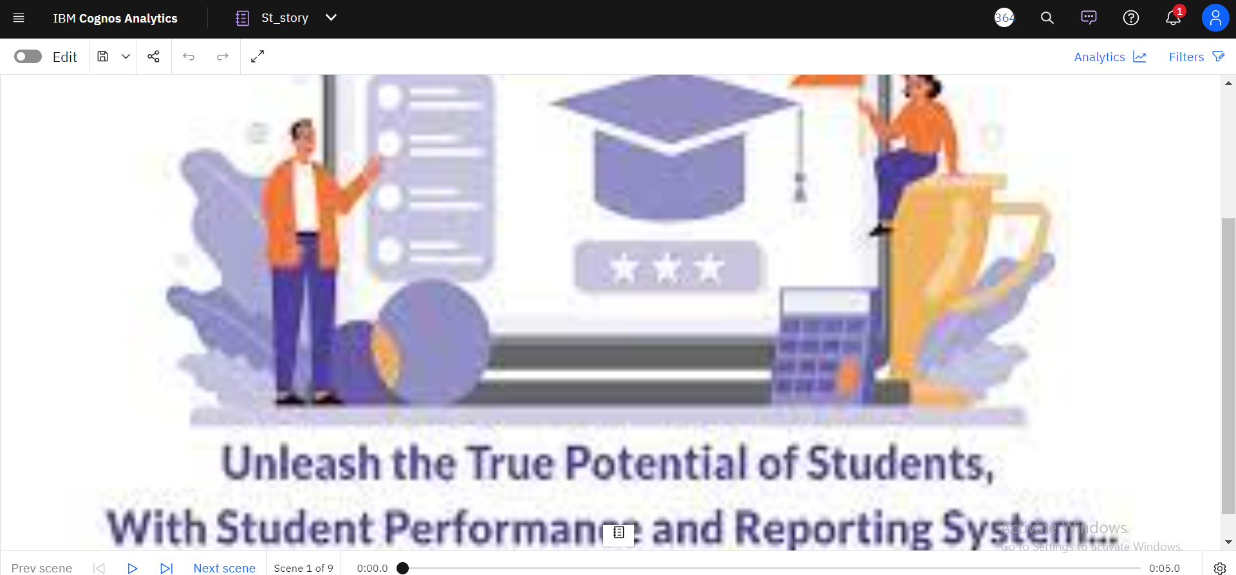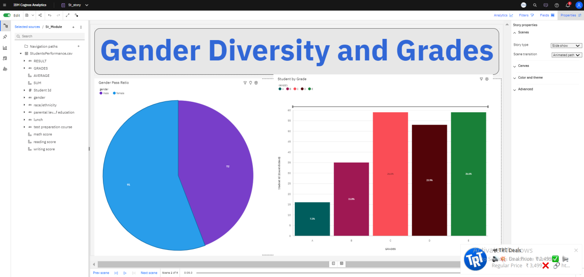

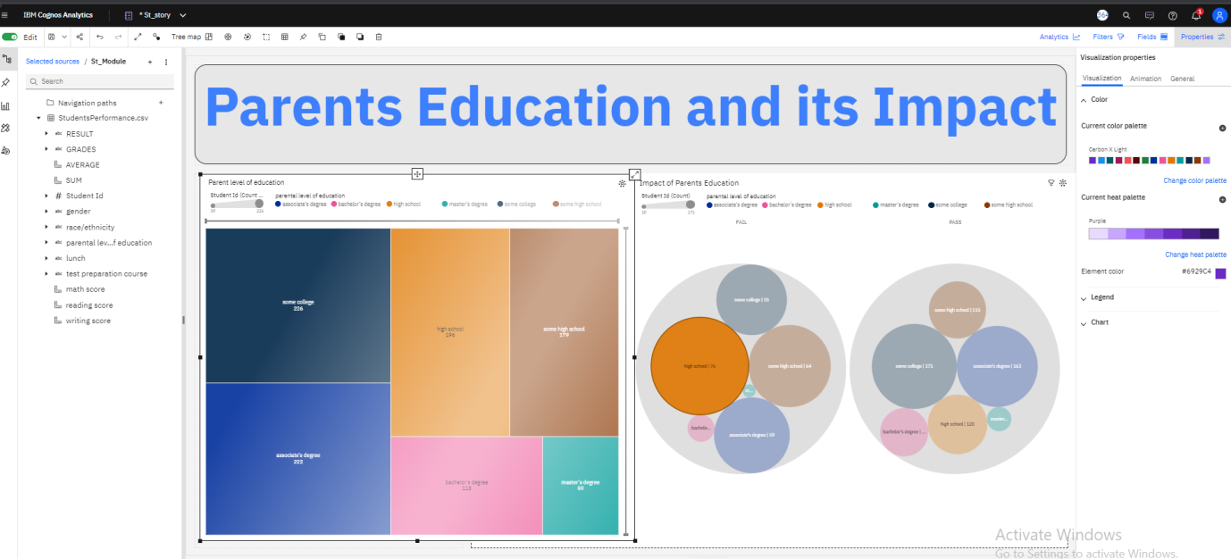

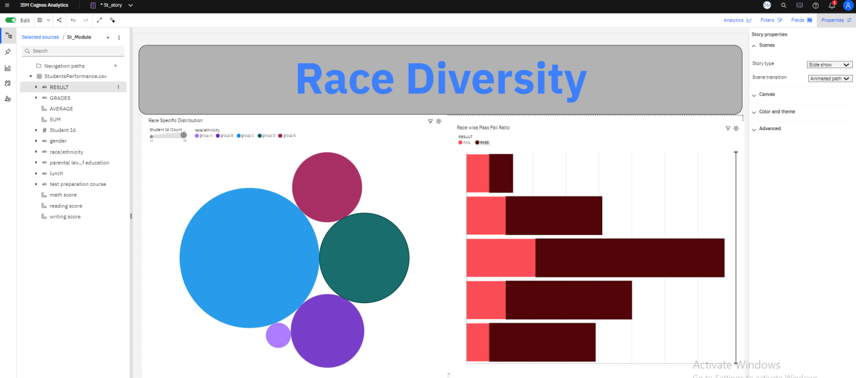

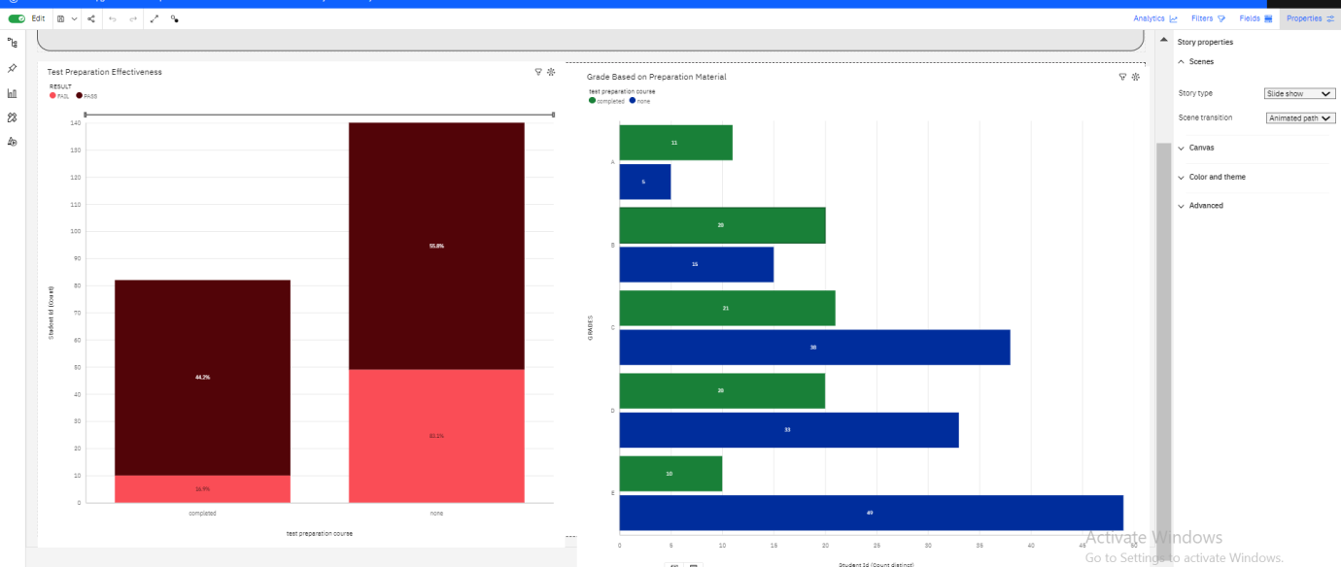

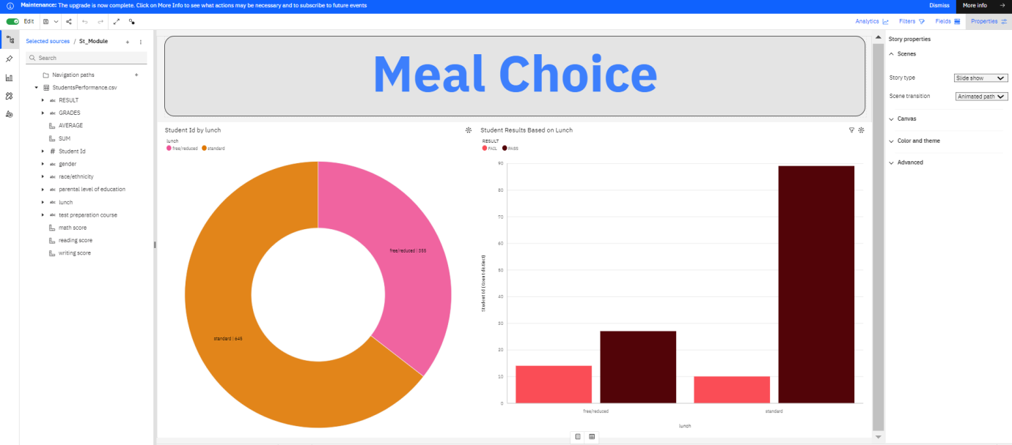

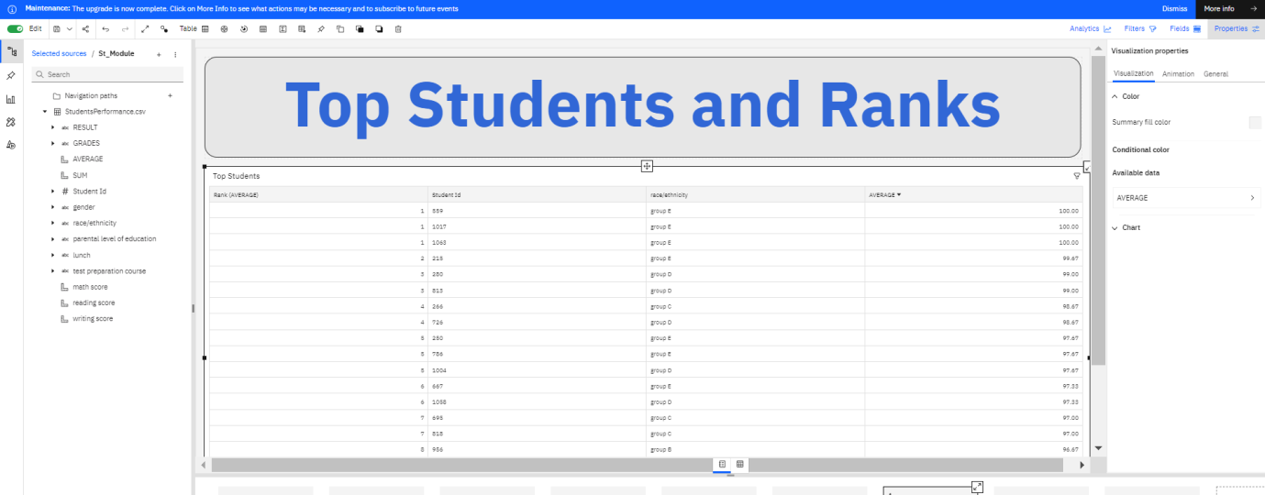

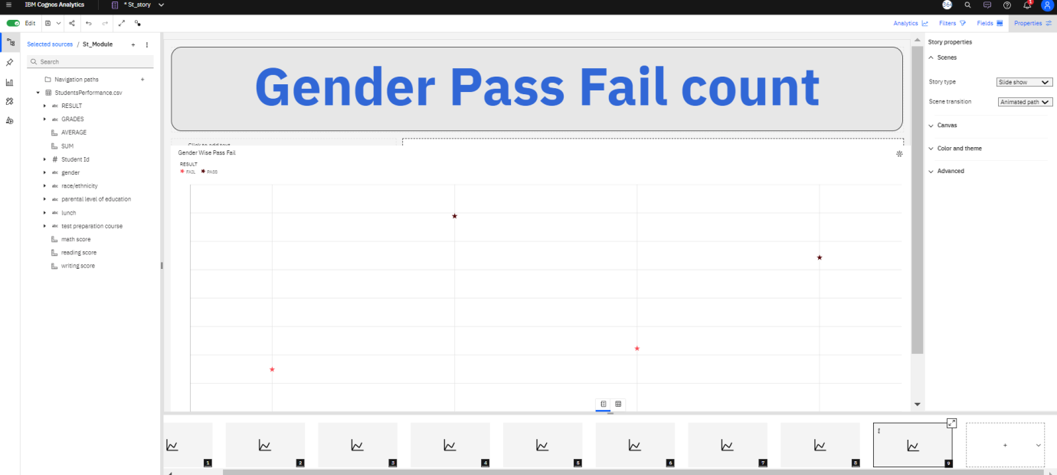

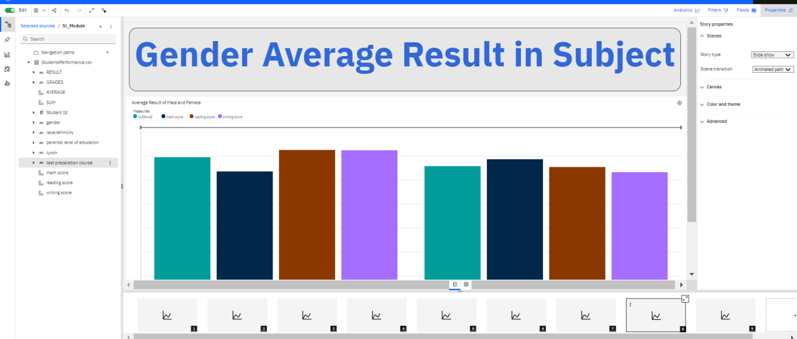

### Report

A report in data analytics typically involves analysing and interpreting data to draw insights and conclusions that can inform business decisions or address research questions. The report usually includes a summary of the data analysis process, including the methods and tools used, as well as the findings and recommendations based on the analysis. The report should begin with an executive summary, which provides a brief overview of the main findings and recommendations. The introduction should provide background information on the problem or research question being addressed and the data sources used.

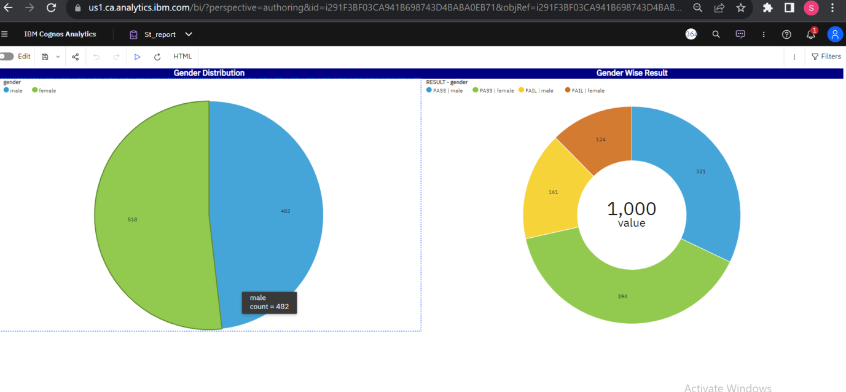

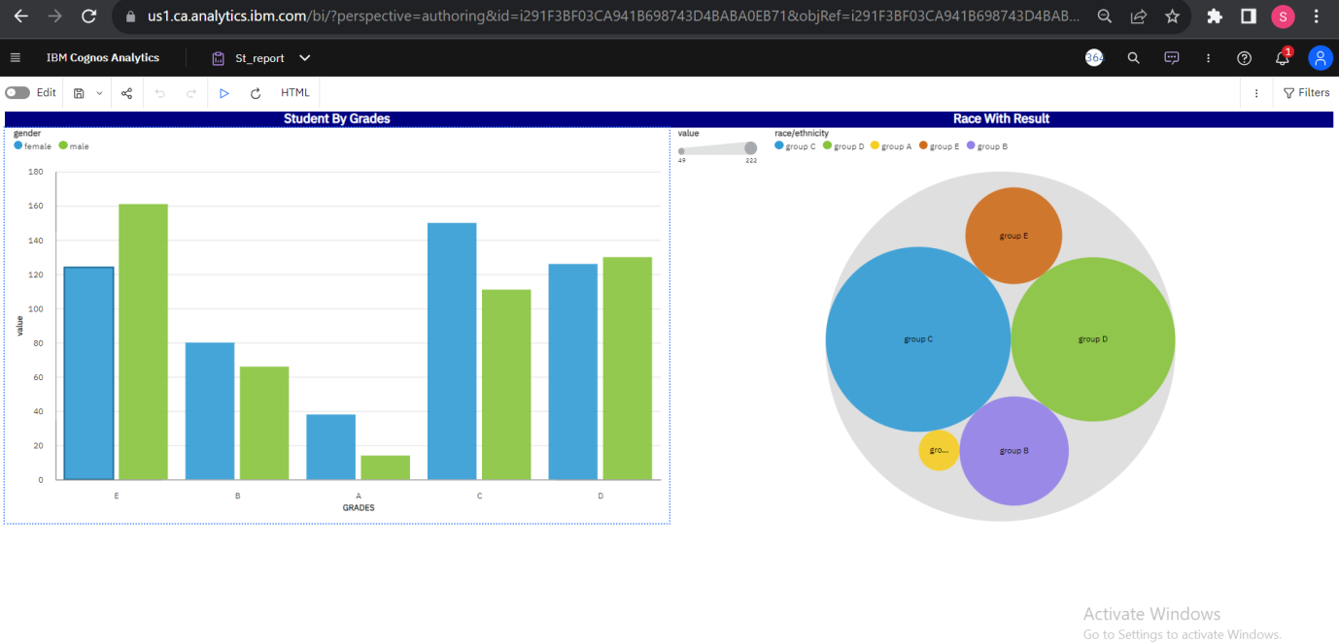

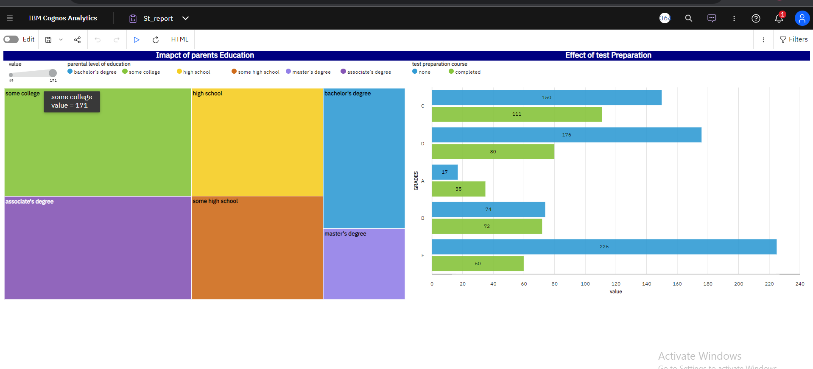

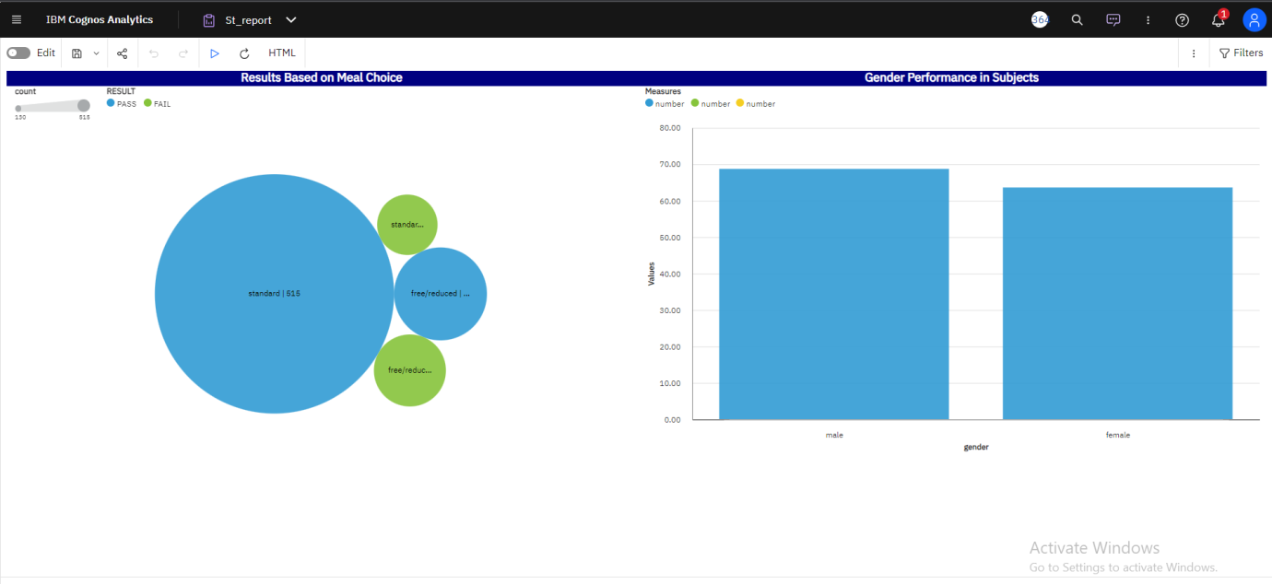

**RESULT**

The result will be show in a web page through web integration

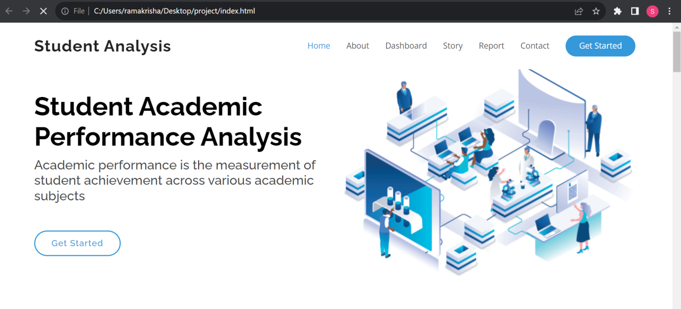

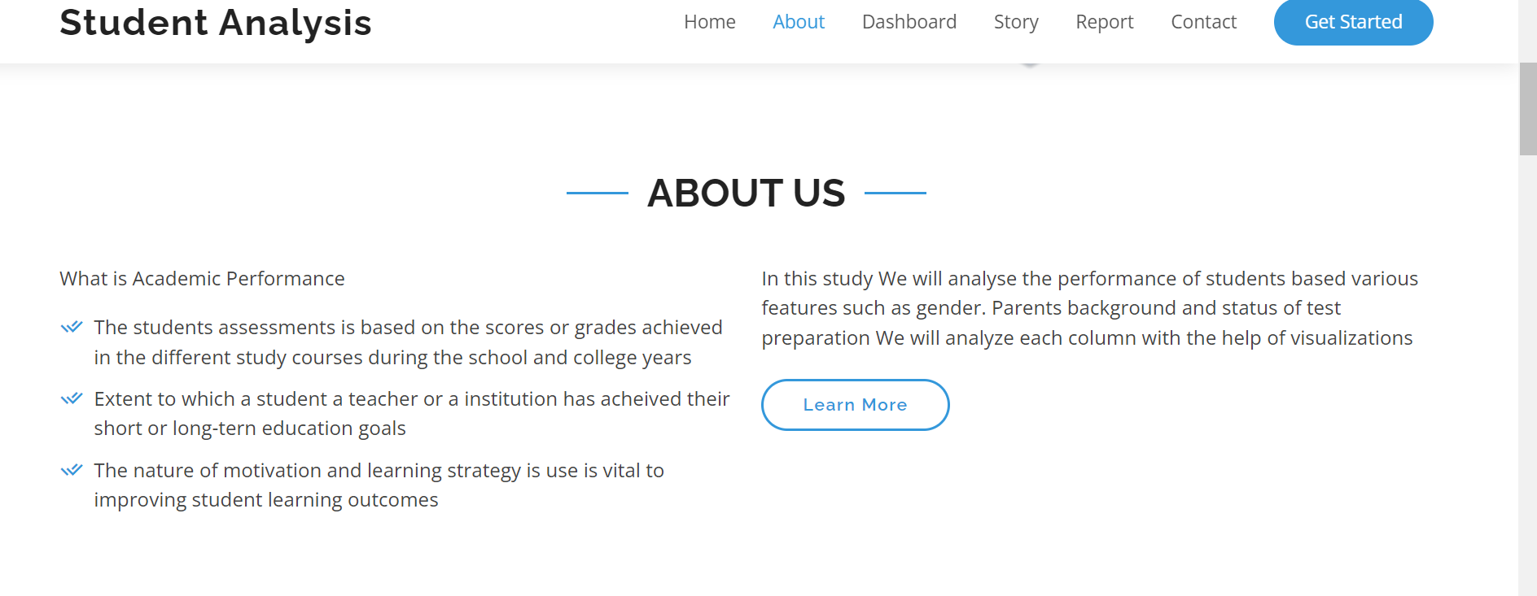

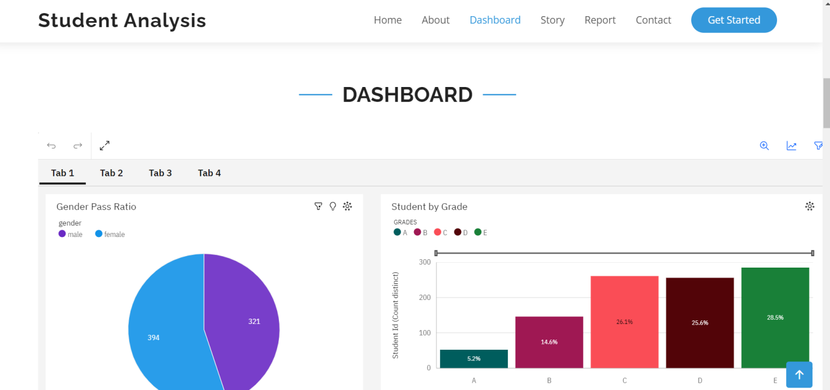

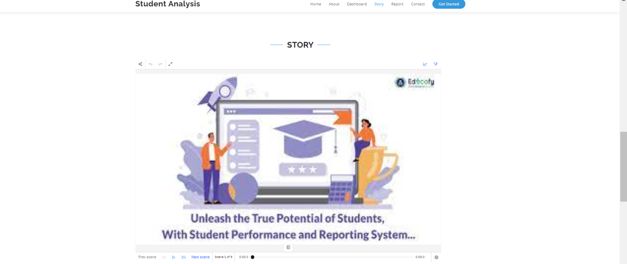

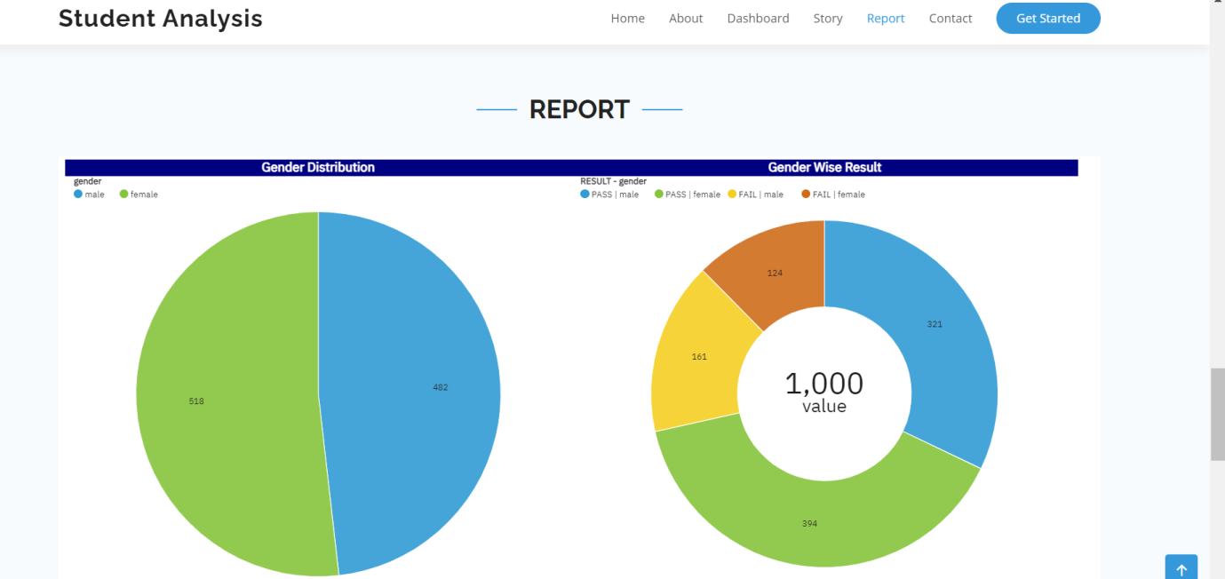

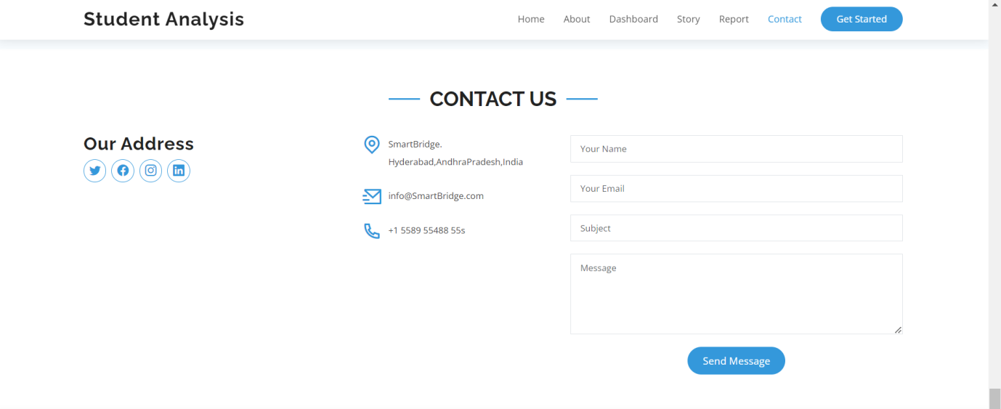

WEBSITE LINK :

<https://durgatejavaka.github.io/student-analysis/>

Github :

<https://github.com/durgatejavaka/student-analysis>

**Advantages of Unleashing the Potential of Our Youth: A Student Performance Analysis**

"Unleashing the Potential of Our Youth: A Student Performance Analysis" offers numerous advantages that can positively impact students, educators, and the education system as a whole. Here are some key advantages:

1. **Personalized Learning**: By analyzing student performance data, the project can identify individual strengths and weaknesses, enabling personalized learning plans. This tailored approach maximizes student engagement and academic growth.

2. **Evidence-Based Decision Making**: The analysis provides evidence-based insights into the factors that influence student performance. Educators and policymakers can make data-driven decisions to optimize teaching strategies and resource allocation.

3. **Early Intervention and Support**: Identifying struggling students early allows for timely intervention and targeted support. This can prevent academic setbacks and help students overcome challenges effectively.

4. **Equity and Inclusivity**: The analysis can highlight educational inequalities and identify marginalized student populations. Implementing targeted interventions can promote equity and inclusivity in the education system.

5. **Teacher Professional Development**: Educators can gain valuable insights from the analysis, enhancing their teaching practices and fostering continuous professional development.

6. **Positive Learning Environment:** By considering factors like emotional well-being and motivation, the project promotes a positive and supportive learning environment, enhancing student well-being and academic success.

7. **Parental Engagement**: The project encourages parental involvement and collaboration with educators, strengthening the support system for students both at home and in school.

8. **Policy Reforms:** Evidence-based policy recommendations can lead to educational reforms that benefit the entire education system, leading to improved learning outcomes.

9. **Innovation and Research**: The project contributes to the body of knowledge in education through the application of data analysis techniques and research methodologies.

10. **Long-term Impact:** By unleashing the potential of youth and nurturing well-rounded individuals, the project fosters a generation of competent and motivated individuals equipped to contribute positively to society.

11. **Optimizing Resources:** The analysis can help identify resource allocation gaps and inefficiencies, ensuring that educational resources are utilized effectively.

12. **Continuous Improvement**: The project promotes a culture of continuous improvement in education, where data is used to inform ongoing adjustments and enhancements to teaching and learning practices.

Overall, "Unleashing the Potential of Our Youth: A Student Performance Analysis" empowers students, educators, and policymakers with data-driven insights and strategies to foster a more inclusive, effective, and supportive education system. This holistic approach ensures that each student's unique potential is recognized, nurtured, and unleashed, leading to better educational outcomes and opportunities for all.

**Disadvantages Unleashing the Potential of Our Youth: A Student Performance Analysis**

While "Unleashing the Potential of Our Youth: A Student Performance Analysis" offers numerous advantages, it is essential to be aware of potential disadvantages and challenges that may arise. Some of the disadvantages include:

1. **Data Privacy Concerns**: Collecting and analyzing student data raises concerns about data privacy and confidentiality. Ensuring that the data is anonymized and securely stored is crucial to protect the privacy of students and their families.

2. **Overemphasis on Testing:** Overreliance on student performance data for analysis may lead to an excessive focus on standardized testing, which might not capture the full range of a student's abilities or potential.

3. **Narrow View of Success**: Relying solely on academic performance data may lead to a narrow definition of success, overlooking other essential aspects of a student's development, such as creativity, emotional intelligence, and social skills.

4. **Bias and Fairness**: The analysis process should be mindful of potential biases in the data collection and analysis, as this could inadvertently perpetuate existing inequalities and disparities in the education system.

5. **Pressure and Stress:** Intense data-driven evaluations can place significant pressure on students, educators, and schools to constantly achieve high performance, potentially leading to stress and burnout.

6. **Limitations of Data Analysis**: Data analysis alone may not capture the full complexity of educational processes and human behavior, as it might overlook qualitative aspects that are challenging to quantify.

7. **Resource Intensive**: Conducting thorough data analysis requires adequate resources, including skilled data analysts, software, and time, which might be a challenge for some educational institutions.

8. **Focus on Short-Term Outcomes**: Overemphasizing short-term performance gains may undermine efforts to promote long-term learning and holistic development in students.

9. **Neglect of Individual Differences**: While data analysis can identify patterns, it may overlook the uniqueness of each student's learning style, strengths, and challenges.

10. **Loss of Teacher Autonomy:** Excessive data-driven decision-making may reduce teacher autonomy and flexibility in the classroom, leading to a standardized approach to education.

11. **Resistance to Change:** Implementing data-driven reforms may face resistance from stakeholders who are apprehensive about shifting from traditional methods.

To mitigate these disadvantages, it is crucial to strike a balance between data analysis and holistic educational practices. Ethical considerations, continuous improvement, and a comprehensive understanding of students' needs are essential for making the most of student performance analysis while addressing potential drawbacks. The project should be designed with sensitivity to the diverse needs and well-being of students and the education community as a whole.

**APPLICATIONS:**

The application of "Unleashing the Potential of Our Youth: A Student Performance Analysis" can have far-reaching benefits across various domains within the education sector and beyond. Some key applications of the analysis include:

1. **Educational Institutions**: Schools, colleges, and universities can use the insights from the analysis to improve their teaching methodologies, curriculum design, and student support services. This can lead to better academic outcomes and a more conducive learning environment.

2. **Teacher Professional Development**: The analysis can inform teacher training and professional development programs, empowering educators with data-driven strategies to meet the diverse learning needs of their students.

3. **Educational Policy Making**: Policymakers can utilize the evidence-based recommendations from the analysis to shape educational policies that promote equity, inclusivity, and improved learning outcomes for all students.

4. **Early Intervention Programs:** Identifying struggling students early through the analysis allows for targeted interventions, such as remedial support or enrichment programs, to prevent academic setbacks and enhance student success.

5. **Parental Engagement**: The analysis can facilitate stronger partnerships between parents and educators, enabling parents to actively participate in their child's education and provide appropriate support at home.

6. **Education Technology (EdTech) Innovation:** EdTech companies can leverage the analysis to develop personalized learning platforms, adaptive educational tools, and data-driven resources that cater to individual student needs.

7. **Education Nonprofits**: Nonprofit organizations focused on education can use the analysis to design evidence-based programs and initiatives that address specific challenges faced by students and schools.

8. **Research and Academia**: The findings from the analysis can contribute to educational research and academic literature, enriching the understanding of student performance and effective educational practices.

9. **Corporate Social Responsibility (CSR):** Businesses and corporations can support projects based on the analysis as part of their CSR initiatives, investing in education and youth development.

10. **Education Consultancy:** Education consultants can use the insights from the analysis to offer tailored guidance and recommendations to educational institutions seeking to improve student outcomes.

11. **Government Agencies and Education Ministries:** Government bodies can utilize the analysis to inform policy decisions, allocate educational resources effectively, and promote educational reforms.

12. **Social Impact Organizations:** Organizations focused on youth empowerment and development can incorporate the analysis into their programs to unleash the potential of young individuals and foster future leaders.

The wide range of applications demonstrates how "Unleashing the Potential of Our Youth: A Student Performance Analysis" can create a positive impact at multiple levels of the education ecosystem, leading to improved educational experiences, increased student success, and a more inclusive and thriving society.

**CONCLUSION:**

In conclusion, "Unleashing the Potential of Our Youth: A Student Performance Analysis" is a transformative project with the overarching goal of empowering the next generation of learners and fostering their holistic development. By delving into the multifaceted factors influencing student performance, this analysis seeks to unlock the unique potential of each student, providing evidence-based insights that can drive positive change within the education system.

The project's data-driven approach offers numerous advantages, including personalized learning plans, evidence-based decision-making, and targeted interventions to support struggling students. It emphasizes the importance of a positive and inclusive learning environment, where students' emotional well-being and motivation are nurtured alongside academic achievement.

Through collaboration with educators, parents, policymakers, and stakeholders, the project aims to bridge educational inequalities and promote equity, ensuring that every student has equal opportunities to thrive and succeed. The analysis also highlights the significance of teacher professional development and parental engagement, recognizing their pivotal roles in students' educational journeys.

While the project presents tremendous potential for enhancing education, it is essential to be mindful of potential disadvantages, such as data privacy concerns and the risk of overemphasizing standardized testing. Ethical considerations and continuous improvement are crucial to ensure that the project's impact remains positive and sustainable.

In its applications, the project finds relevance across various domains, from educational institutions and policy-making bodies to EdTech innovation and social impact organizations. The knowledge gained from the analysis can drive evidence-based reforms, educational innovations, and research endeavors, enriching the education sector at large.

Overall, "Unleashing the Potential of Our Youth: A Student Performance Analysis" holds promise in shaping a more equitable, inclusive, and effective education system. By harnessing the power of data, research, and collaboration, this transformative project endeavors to empower our youth, preparing them to become confident, competent, and compassionate leaders of tomorrow. With unwavering commitment, stakeholders can work together to ensure that every young mind is provided with the nurturing environment they need to unleash their full potential and make a meaningful impact on their communities and the world.

**FUTURE SCOPE**

The future scope of "Unleashing the Potential of Our Youth: A Student Performance Analysis" is promising, with potential for continuous growth and impact. As technology, research, and educational practices evolve, the project can further expand its influence and contribute to positive advancements in the education sector. Here are some key future prospects for the project:

1. **Advanced Data Analytics and AI:** As technology advances, the project can leverage more sophisticated data analytics techniques and artificial intelligence (AI) algorithms to gain deeper insights into student performance. This may include natural language processing for analyzing qualitative data from student surveys and sentiment analysis to understand emotional well-being.

2. **Predictive Analytics for Early Intervention**: Implementing predictive analytics can enable the project to identify students at risk of academic challenges even earlier. By forecasting potential issues, educators and support systems can intervene proactively to prevent academic setbacks.

3. **Personalized Learning at Scale:** With a growing dataset and refined data analysis, the project can scale personalized learning initiatives to reach a larger number of students. This approach can cater to individual learning needs more effectively and improve learning outcomes on a broader scale.

4. **Longitudinal Studies for Lifelong Impact**: Expanding the project to include longitudinal studies can track the long-term impact of interventions and educational practices on students' lives beyond formal education. Understanding the lifelong effects of the interventions can lead to more comprehensive and sustainable strategies.

5. **Cross-Cultural and International Comparisons:** Collaboration with educational institutions and researchers across different regions and countries can facilitate cross-cultural and international comparisons. This can offer valuable insights into best practices globally and promote knowledge exchange.

6. **Integration of Emerging Technologies**: The project can explore integrating emerging technologies, such as virtual reality (VR) and augmented reality (AR), to enhance learning experiences and engagement for students.

7. **Emphasis on Emotional Intelligence**: Given the increasing recognition of emotional intelligence in personal and professional success, the project can focus on incorporating emotional intelligence development into educational practices.

8. **Policy Advocacy and Implementation**: Based on its findings, the project can actively advocate for evidence-based policy changes at various levels of the education system, driving reforms that promote student success and well-being.

9. **Public-Private Partnerships**: Collaborating with private entities, non-profit organizations, and government agencies can enhance the project's resources and impact, ensuring a more comprehensive approach to unleashing youth potential.

10. **Sustainability and Continuity**: Ensuring the sustainability and continuity of the project through long-term funding, partnerships, and stakeholder commitment is essential for its ongoing success and impact.

By staying adaptive, innovative, and focused on the needs of students, "Unleashing the Potential of Our Youth: A Student Performance Analysis" can continue to shape the future of education, preparing generations of empowered individuals ready to tackle the challenges of an ever-changing world. With a commitment to evidence-based practices and collaborative efforts, the project's future scope holds the potential to leave a lasting and positive mark on education and society at large.